9-1-1
Websites, devices and apps, Oh my!!!!!
Why do I need an app for 9-1-1? At first it seems like a silly idea, dialing 9-1-1 is pretty simple. However after looking at these apps in this presentation some of them do offer useful features. Some of these are devices, web services or functions of the device but the term apps seems to be coming a term that is all encompassing.
Many offer choices for police, fire and medical help. While New Jersey has 9-1-1 statewide these apps are developed to be used anywhere in the world. And some places may not have a single 3-digit number for emergency services. Each may have a separate phone number. Some offer additional choices. Why will become clear when we discuss the features of these apps.
The main benefit is that they offer the estimated location of the caller. This may be in the form of the latitude and longitude and/or an address. This information comes from a source other than the one used by our 9-1-1 network to display on the ALI screen. We will talk about the accuracy during the presentation.
  - APPS

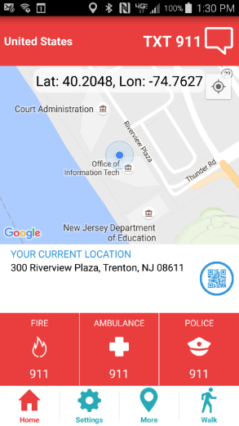
9-1-1 Help
The first app is 9-1-1 Help (we are using the “Lite” version”). When opened it will offer the location in latitude and longitude and suggest an address. The caller can use this information when they call 9-1-1. It offers the choice of a voice call to Police, Fire or Medical or sending a text to 9-1-1. If a text is selected the initial message delivered to the PSAP will include the location information and the name of the person stored on the phone.

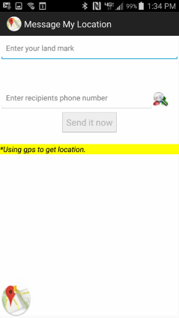
Message My Location
Not a 9-1-1 app, it is intended for people to use to share location information to arrange social meetings. If 9-1-1 is in in the user’s contacts then it will send a text message to 9-1-1 offering the sender’s location but little else. The sender will have to offer the type of emergency and other details.

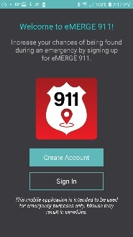
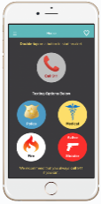
eMERGE 911
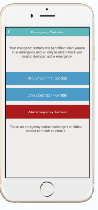
When activated it will send a text message to 9-1-1 with your names, location, phone number, type of help requested and a link to your tracking information. The PSAP can click on the link and receive the caller’s location on a map. The caller will also be able to send live video to the PSAP over the same link as the location. Text messages can be exchanged during this process. In addition, the program can also send text alerts to family and friends.

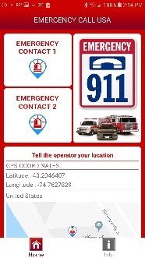
Emergency Call USA
When activated calls 9-1-1. The screen will offer the caller’s location which they can the caller can give to the PSAP. Personal information can be stored on the app and text notifications will be sent to selected emergency contacts.

Rapid SOS Haven
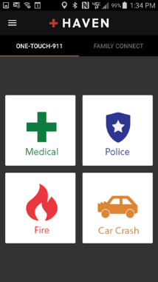
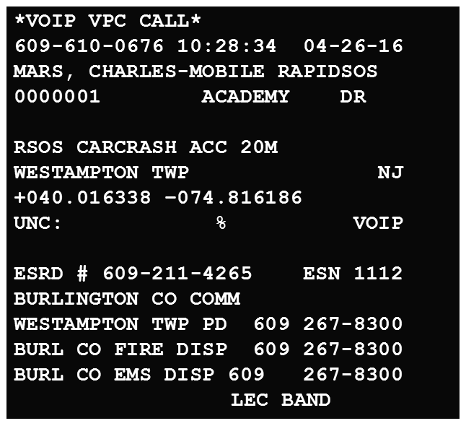
When activated it offers the estimated location as latitude and longitude and an address. The caller presses one of the buttons and the call is placed. Texting is not an option. The call will be offered to the PSAP over the 9-1-1 trunks. If the caller does not speak the app will use a computer generated voice to offer the name of the phones user, the type of help requested based on which button was used and the address suggested by the latitude and longitude. On the example ALI screen this call was made using one of our work issued cell phones. Notice that it was delivered as a VoIP call with the call back number, name of the user, an address and the type of emergency. In this case the call was placed from the Burlington County Communications Center, located at 1 Academy Drive in Westampton Twp. Without help for the caller it used the address to route the wireless call like a VoIP call.

The Haven app also includes access to RapidSOS’ Family Connect feature. For the first time, people can call 9-1-1 on behalf of a loved one, transmitting their loved one’s location and relevant data directly to the dispatch center closest to them. Additionally, Family Connect allows users to share their location with loved ones, see family members’ real-time locations without the distraction of a phone call or text, and easily and discreetly ask family and friends for help.

Vitals Aware Services
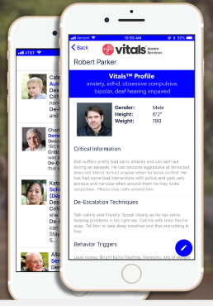
Vitals™ Aware Services, is a Twin Cities-based company building technology for social good. The Vitals™ app enables safer community interactions by allowing individuals with visible and invisible conditions and disabilities to create and share a personalized digital profile with authorized first responders via a secure, mobile app – improving real-time communication, reducing the risk of misunderstandings, and promoting greater independence.
First responders that come within 80 feet of a Vitals™ beacon are automatically notified and given information on how to best serve and protect the individual – reducing the risk of misunderstanding and negative interactions.
https://thevitalsapp.com/

  - DEVICES

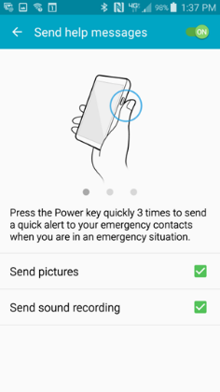
Safety Assistance
A feature found on Samsung Galaxy phones (S4 and newer). If activated in the settings on the phone it will automatically send a text message to 9-1-1 indicating that the person whose name appears registered to the phone is requesting assistance at the latitude and longitude offered by the cell phone. If the PSAP texts back the sender can continue the conversation. To activate the sender has to press the “power button” on the side of the phone 3 times in rapid secession. The phone will give no audible indication that it is sending a text.

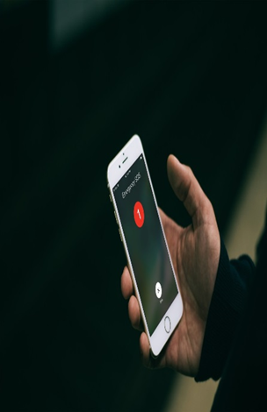
Emergency SOS
Apple devices have a similar function that can be activated in settings. This can be configured to send a text message to 9-1-1 and/or others in the phones contact list. To activate the “power button” must be pressed 5 times in rapid secession.

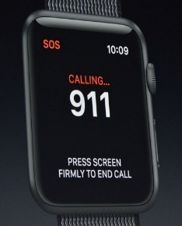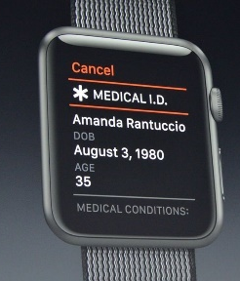

SOS
If the user has an Apple Smart Watch this has a function that will call 9-1-1 by pressing and holding the side button. Medical information can also be displayed.

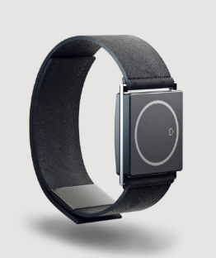
Embrace
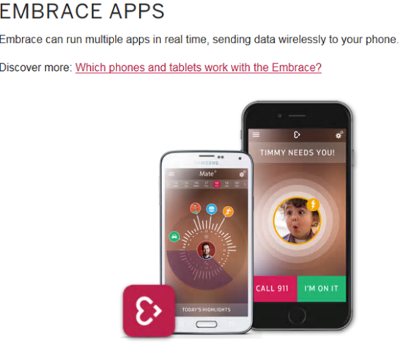
This is the first medical device we have identified that will contact 9-1-1 in an emergency. It is worn by a person with a diagnosed seizure disorder. When it detects the onset of a seizure it will text caregivers and 9-1-1 offering the patients name, estimated location and that they are experiencing a seizure.

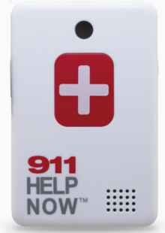
911 Help Now
A device worn by the user. When activated it will make a 9-1-1 call in the same way a cell phone without a service contract can call 9-1-1. There will be no callback number only 911-NNN-NNNN. The ALI screen may offer Phase II information but how accurate it will vary with the carrier. There is no GPS service. The location will have to be obtained from the caller.

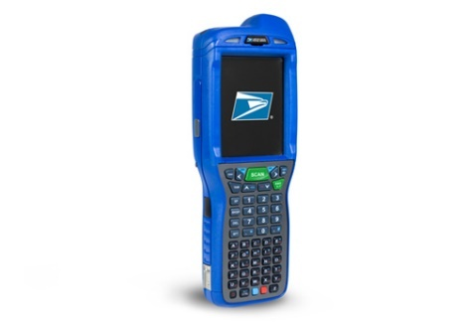
United States Post Office
The package scanners in use by the USPS that records and tracks deliveries has a cellular radio that can also be used to call 9-1-1. In an emergency the call will be routed based on the device location to the PSAP as a VoIP call (VOIP) not a wireless call (WHP1, WPH2). The LEC field will display “USPS”. No address will be offered only the latitude and longitude. It Is unknown if “rebidding” will update the location information. When activated the device will use a callback number drawn from a pool of numbers. If the call is disconnected the PSAP will be able to call back using the number displayed on the ALI screen for up to 12 hours. The person using the device will not know what number is being used.
  - WEBSITES

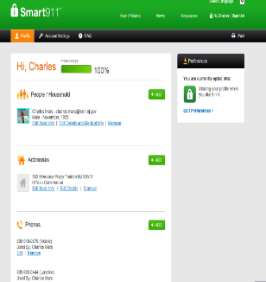
Smart 9-1-1
Not an app on the phone it is a web based service. A person can open an account and enter as much information as they like about themselves, family members, medical history, work, vehicles, pets, etc. When a call is made to 9-1-1 with a phone registered on the account the PSAP will be offered access to this information over a link to the website. The PSAP must subscribe to the service to access the website.
PSAPs that are using the GEM 911 web interface for Text to 9-1-1 are receiving Smart 9-1-1 service as part of the package. However, it is only on text messages.

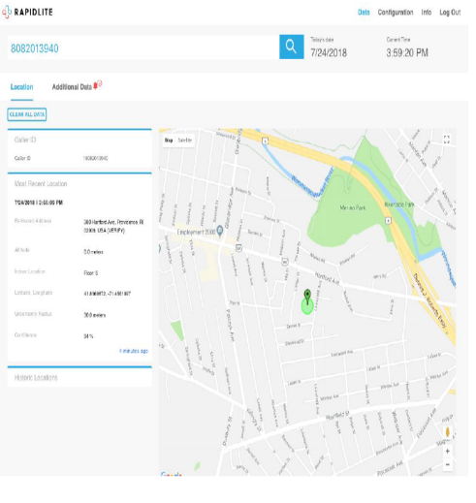
Rapid SOS (Lite)
This is a web based service. The PSAP enters the caller’s cell phone number on the website. This will open a window showing the most recent location and display that on a map. It can be integrated with the PSAP CAD or used as a stand-alone.

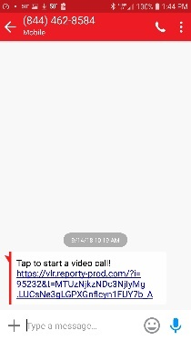
Carbyne
A web based service available to the PSAP that can provide location, pictures and streaming video from the caller. The PSAP enters the callers cell phone number on the provider’s website. The caller will receive a text message asking them to click on the link sent from the provider. The caller will be asked if they will allow the location of their phone to be sent. Then a message will ask if they will allow access to their camera. If the caller agrees the PSAP will get the location in the form of latitude and longitude displayed on a map with the live video. The caller’s location will be updated allowing the PSAP to see their route of travel.

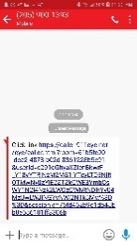
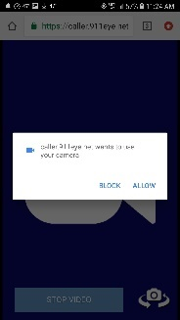
911eye
A web based service available to the PSAP that can provide location, pictures and streaming video from the caller. The PSAP enters the callers cell phone number on the provider’s website. The caller will receive a text message asking them to click on the link sent from the provider. When they do they will see the PSAP logo and a message saying 911eye wants to use their devices location which they can block or allow. Then they will receive a message 911eye wants to use your camera which they can block or allow.
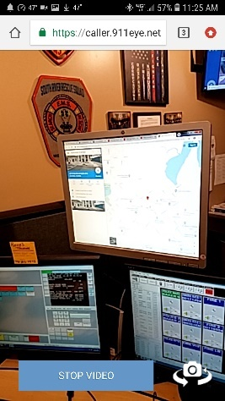
Allowing both will show a map with the caller’s location and the live video from the caller’s phone. The session can be ended by either the caller or the PSAP at any time. When ended the caller will receive a text message indicating the session is ended and see a receipt for the video or photo sent.

Central Square (TriTech) CLQ
TriTech Caller Location Query feature is web based and can be used with their CAD products or as a standalone. The caller’s cell phone number is sent to the website which will return a location in the form of latitude and longitude displayed on a map.

Uber
This new feature will be part of the 911 Assistance button housed inside Uber’s Safety Toolkit. Riders and drivers will be able to choose between texting or calling 911 should they need emergency assistance while on a trip with Uber.

When used, the text to 911 feature populates an SMS text message to 911 with key trip details including locations and vehicle information. Uber product managers consulted with 911 dispatchers to determine which information to include in an initial text message to 911. Below is a sample initial text message:

- I am taking a trip with Uber. White Toyota Prius ABC1234. My Current location is 1562 Poblano Street. My intended destination is 1455 Market St. My emergency is:

Riders and drivers will be able to include additional information about their emergency before sending a text message to 911 dispatchers. Dispatchers will be able to stay in communication with the person who reached out until law enforcement makes contact.

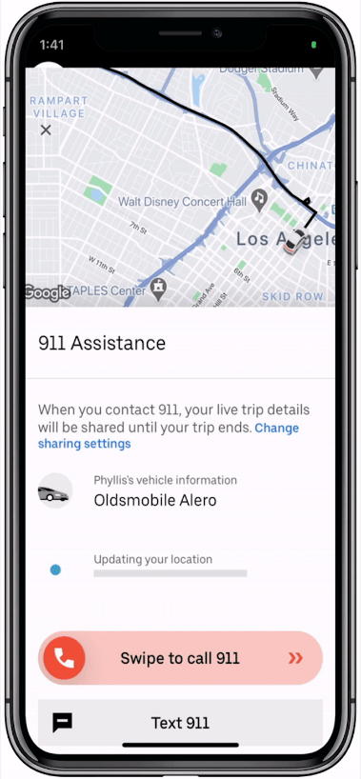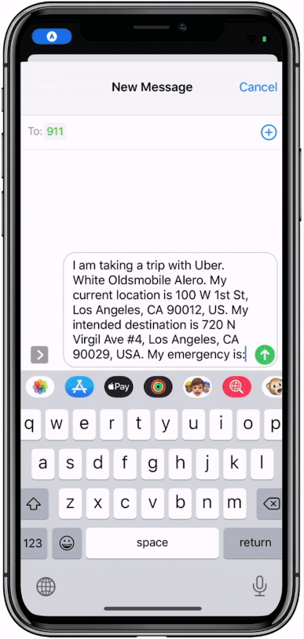

When used with the Rapid SOS Portal additional information including real-time mapping may be available with both the voice and texting features.

Invisawear
Just double click the back of the charm to send an immediate S.O.S
Your 5 personal contacts will be alerted via text message with your GPS location & S.O.S alert.
If you have the free and optional contact 9-1-1 feature enabled, your emergency contacts will be connected via phone call with the nearest 9-1-1 dispatchers who will be able to view your location on their screen
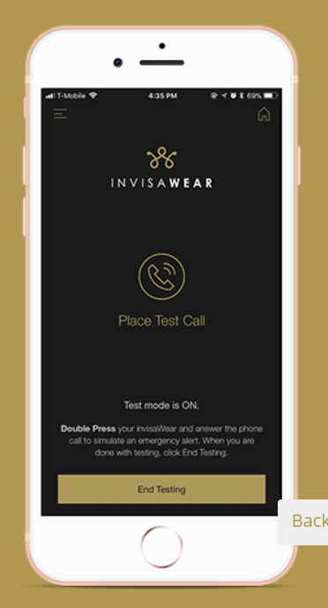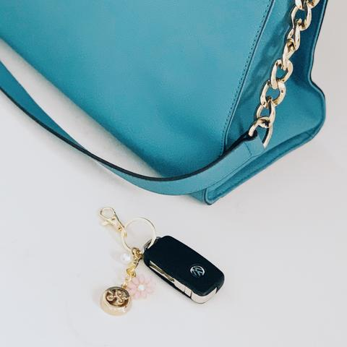

OETS is not recommending or endorsing any of these apps or devices. Our intent is to collect as much information as we can and pass it on the PSAPs and PSDPs so that they will be aware of these in the event they receive an emergency call or text. If you become aware of any apps or devices that are not in this presentation, please send the information to our office.

